**The Brief**

A client would like you to create a web page that will display the weather for a given location. For example, a user would enter a town or city in a text search field then click a search button, after submitting the location, the page will display the weather forecast for the next 5 days.

**Requirements**

The web app should be single page.

Responsive design.

It should have a search text field where the user can enter a location, such as town or city. Once a user submits their search location, the weather forecast for the next 5 days should be displayed.

It should display the following weather information for each day: date, day of the week, condition (sun, rain, cloudy etc…), temperature (Celsius) and wind speed.

The web app should make API requests to retrieve relevant information, such as location and weather data.

**Supporting Information from Client**

Weather / Location APIs

Here are open source APIs you can use for geo-location and weather information. You do not have to use these and can use any open API you wish.

Geo-location API: <https://open-meteo.com/en/docs/geocoding-api>

Weather forecast API: <https://open-meteo.com/en/docs>

Wireframe Designs

The client has provided a basic wireframe design for you to build against (Figure 1 & 2).

Where ***Header*** is specified in the wireframe designs, please come up with a name for the web application.

**Further Information**

Please complete this task using Github showing your development activity.

When finished, please send us a link to your Github repository as well as any instructions or README files on how to run the web app.

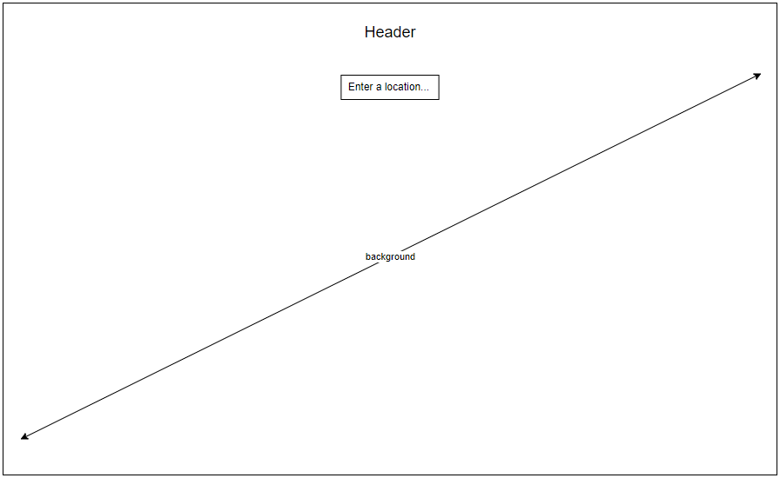

Figure 1: Initial Search Wireframe

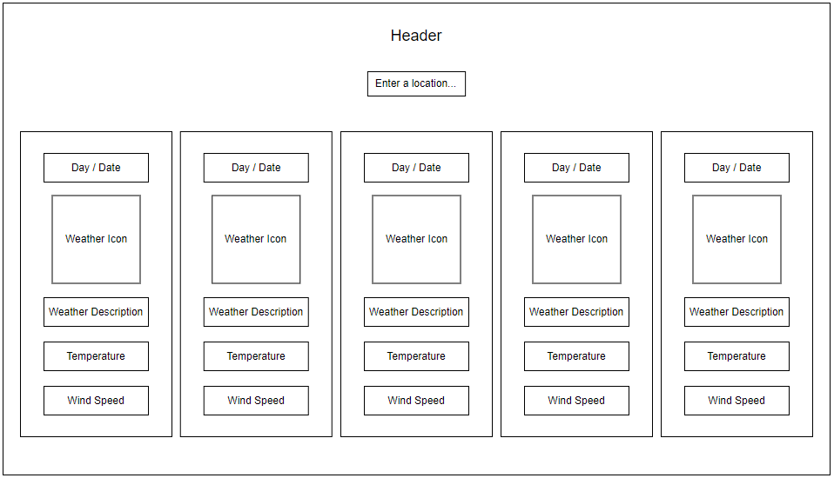

Figure 2: Weather Search Submitted Wireframe